Mongoose 101

First, Download Mongoose
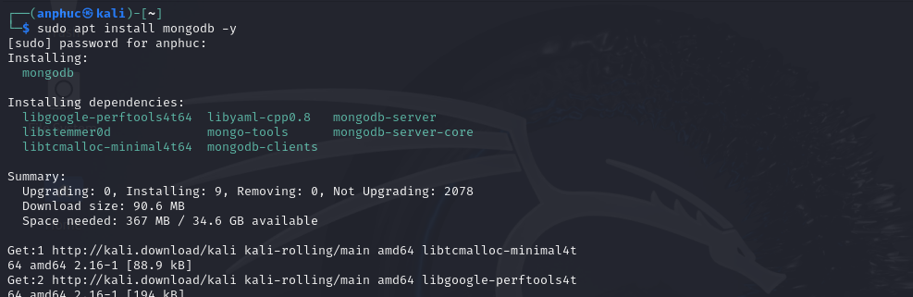

Create dir mongoose-lab and build env
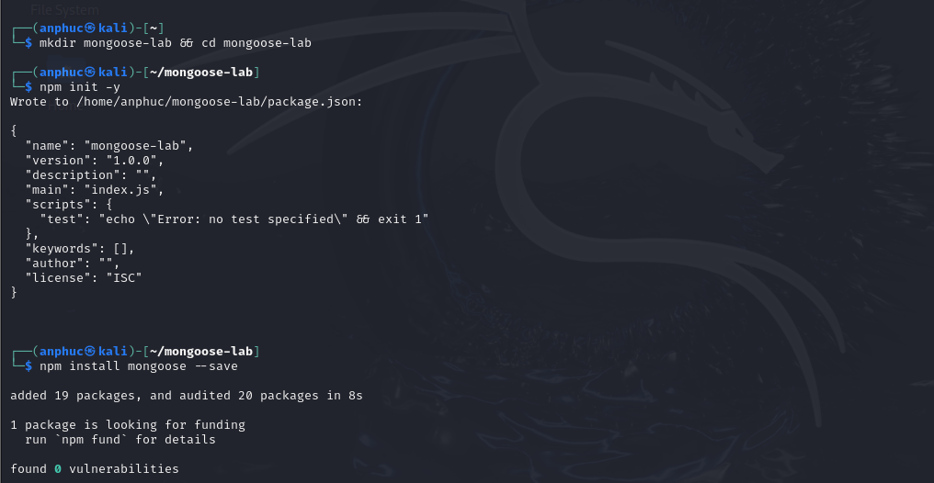

Create a new index.js file
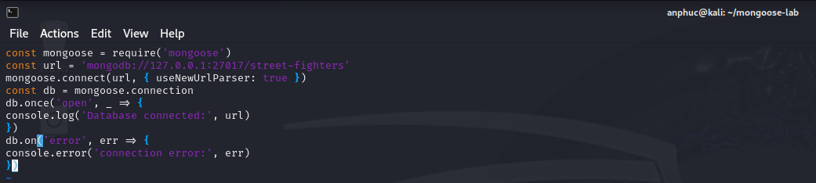

Test

Creating a Model
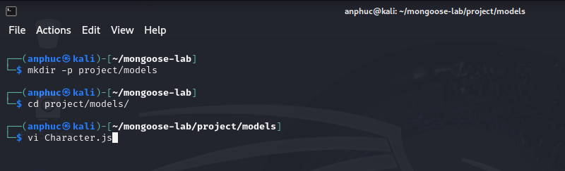

File Character.js
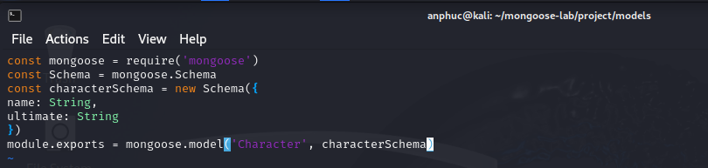

Creating a character
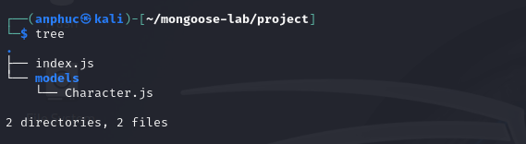

Edit file index.js
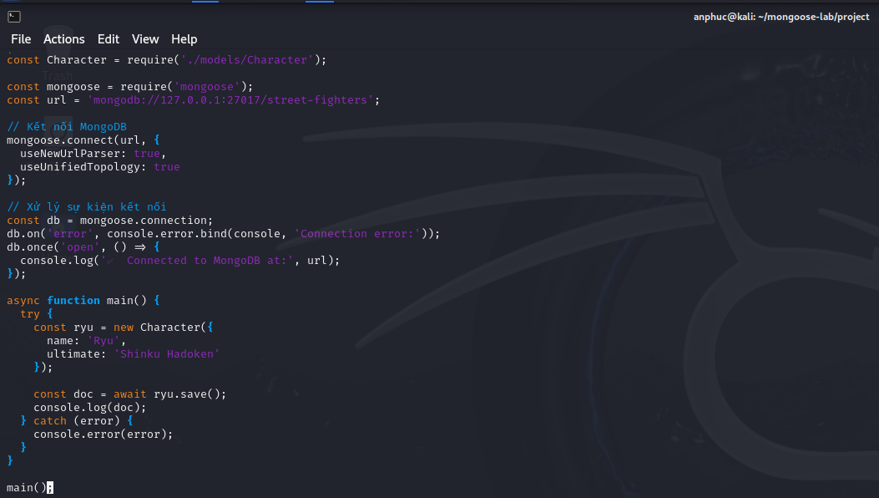

Test run node
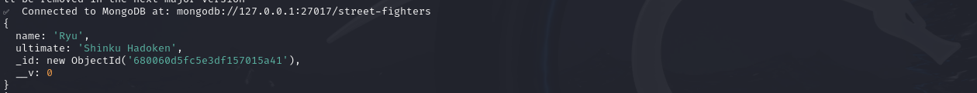

Promises and Async/await

Uniqueness

Sửa file index.js để sử dụng Async/Await
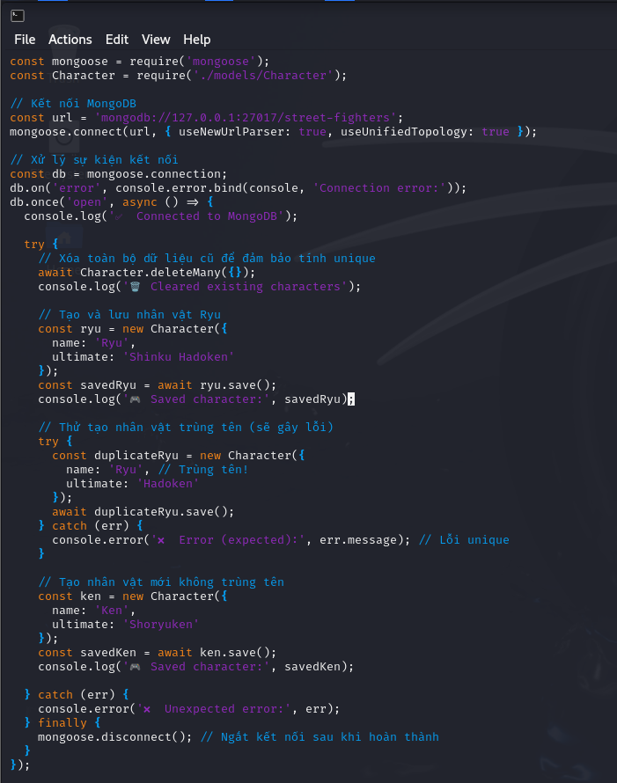

Run
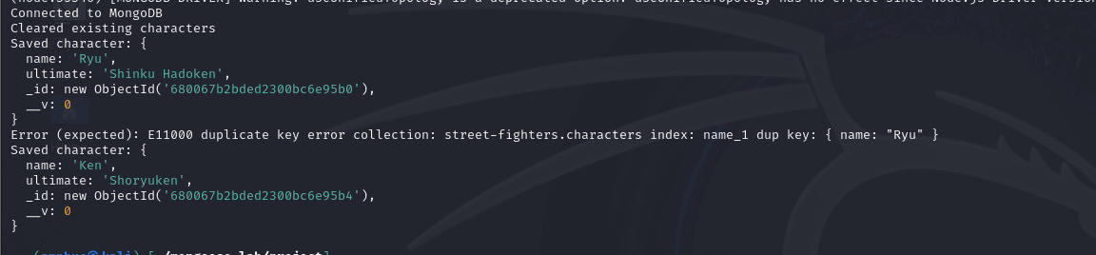

Check mongoose
